**EXPERIMENT NO - 6**

**DML COMMANDS (COLLEGE SCHEMA)**

**Aim:**

* Insert 5 instances into the tables created in experiment 6.
* Display the tables.
* Add attribute course to student table then insert values.
* Use update to set course for students.
* Delete an attribute.

**Components:**

1. DML(Data Manipulation Language):The SQL commands that deals with the manipulation of data present in the database belong to DML or Data Manipulation Language and this includes most of the SQL statements.

Examples of DML:

* + [INSERT](https://www.geeksforgeeks.org/sql-insert-statement/) – is used to insert data into a table.
  + [UPDATE](https://www.geeksforgeeks.org/sql-update-statement/) – is used to update existing data within a table.
  + [DELETE](https://www.geeksforgeeks.org/sql-delete-statement/) – is used to delete records from a database table.

**CODE**



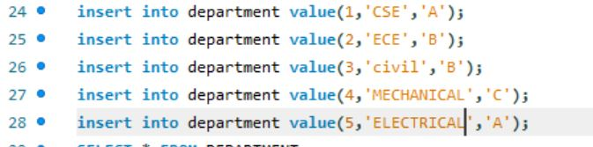

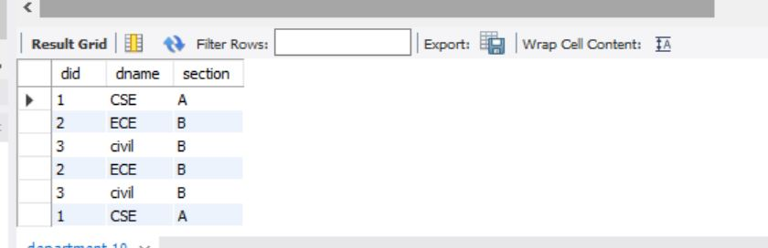

code

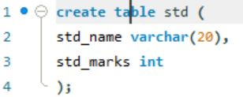

output

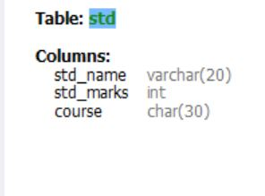

code

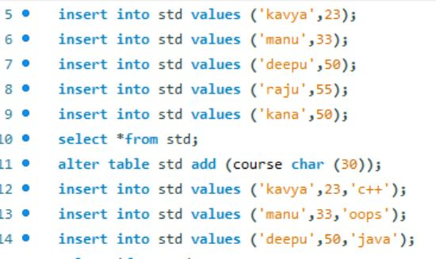

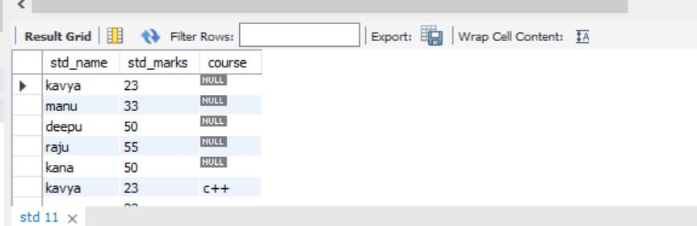

OUTPUT

